4-Soil Texture

This module is used to estimate the maximum amount of water that can be stored in a soil profile for the stand grid cells in a soil zone It is invoked once at the beginning of each simulation. This estimate is based on the soil texture class, the depth of the soil in cm, and the percentage of the soil with fragments greater than 2 mm in size that is specified in the SoilZones.prm file. Landscapes are divided into different soil types, the location of which is described in the SoilZones.asc grid file (Figure 3-1).

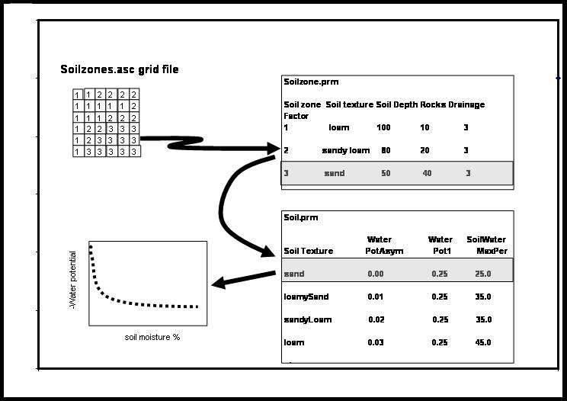
Figure 3-1. Description of soil properties used by the LANDCARB model.

SoilTexture Function.

This function determines the maximum amount of water storage in a soil based upon the soil texture, depth, and rockiness. The output of this function is sent to the CLIMATE module and used in the WaterPot and WaterStores functions.

This function first determines the fraction of the soil that can store water between field capacity and the wilting point (SoilWaterMaxPer) based on the soil texture class specified by the SoilZones.prm file for each soil type. SoilWaterMaxPer is set for each soil texture class contained within the Soil.prm file.

The volume of rocks is used to decrease the overall water holding capacity. The fraction of the soil profile with fine soil (FineSoil) is calculated:

FineSoil=(100-Rocks)/100

where Rocks is the percentage of the soil with fragments greater than 2 mm diameter as specified in the SoilZones.prm file for each soil type.

Finally, the depth of soil that can store water (SoilWaterMax) in cm is calculated from the soil texture, rock content, and soil depth (in cm):

SoilWaterMax=SoilWaterMaxPer*SoilDepth*FineSoil

where SoilWaterMaxPer is the percent of fine soil that can store water from field capacity to wilting point, SoilDepth is the depth of the soil (in cm) as defined in the SoilZones.prm file for each soil type, and FineSoil is the fraction of the soil that is fragments less than 2 mm diameter.

